2024-25 Woodland Elementary Supply List for Grade 5

2 -Packs Sticky Notes  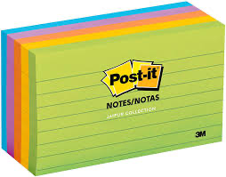 | 4 – Packs of Pencils  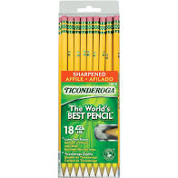 |  | 3 – Glue Sticks 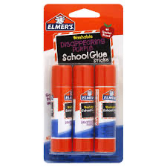 |  | 1 – Pair Child Scissors  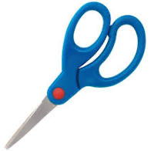
6 – Dry Erase Markers  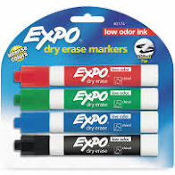 | 3 – Thin sized Highlighters  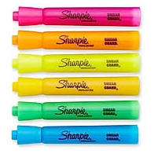 |  | 2– Box of Tissues  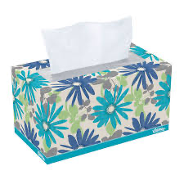 |  | 2 of Each Color: Red, Blue, Green pocket folders with prongs.  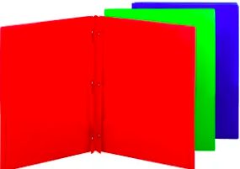
2 – Packs of Colored Pencils  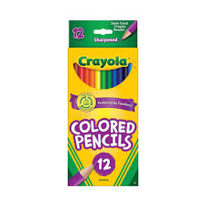 | 1-ream of white printer/copy paper  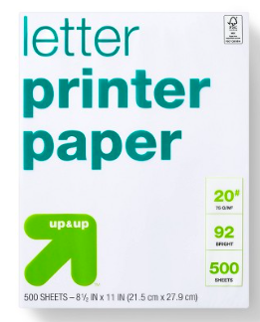 |  | 2 – Yellow Spiral Notebooks  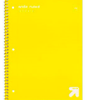 |  | 2 – Red Spiral Notebooks  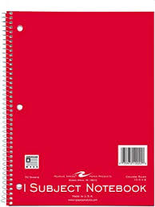
2 – Blue Spiral Notebooks  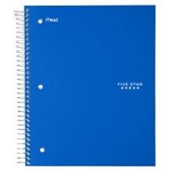 | 2 - Green Spiral Notebooks  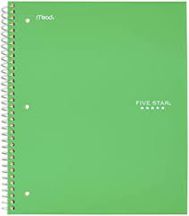 |  | 1 – Box of Quart Size Ziploc Bags 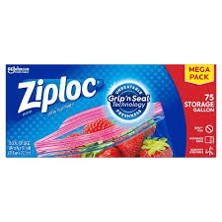 |  | 1 – Package Wipes  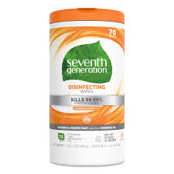
1 - Pair Earbuds  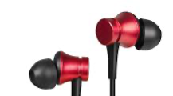 |  | 1 – Pencil Box or Pouch 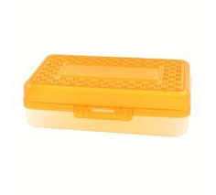 |  | 1 – Bottle Hand Sanitizer  