Kindergarten Supply List

Please label your child’s supplies with his/her name. Due to limited storage space, please only send in items that are on the list.

SUPPLY LIST
1 – Full Size Backpack (no wheels please)  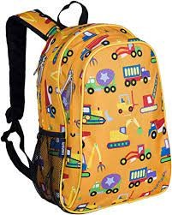 | 2 – Packs of #2 Pencils  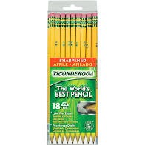 | 12 –Elmer’s Glue Sticks  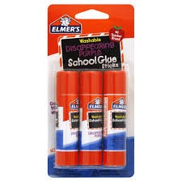 | 1 – Pair Blunt Tip Child Scissors  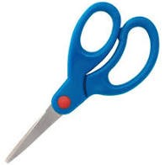
6 – Black Expo Dry Erase Markers  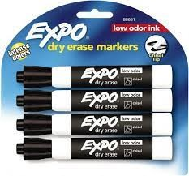 | 1 – Pair of Headphones  (no earbuds)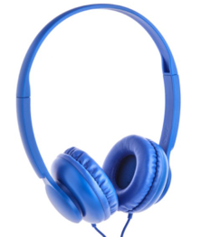 | 2 – Boxes of Tissues  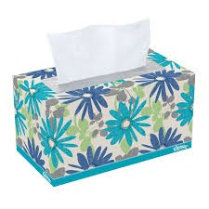 | 4 – Boxes of 24 ct. Crayola Crayons  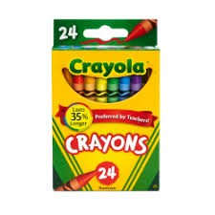
1 – Composition Notebook  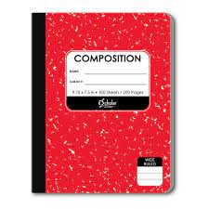 | 1 –Plain Plastic Pencil Box  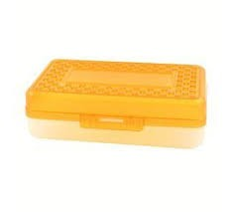 | 1 – Box of Sandwich and 1- Box of Gallon Ziploc Bags  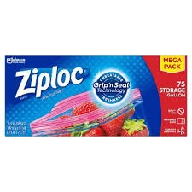 | 2 – Packages of Baby Wipes  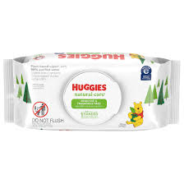
1 – Bottle of Hand Sanitizer  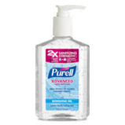 | 4 – Pocket Folders: 1 red, 1 green, 1 blue  and 1 yellow  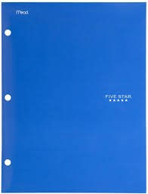 | 1-3 ring binder pouch  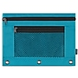 | 2-Reams of white copy paper  