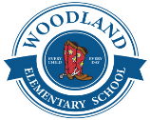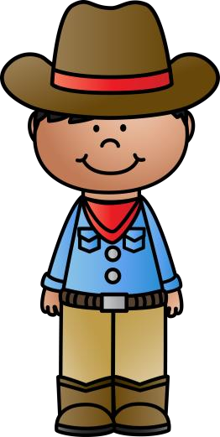Woodland First Grade Supply List 

|  |  |  |  |  |  |  |  |  |  |  |
| --- | --- | --- | --- | --- | --- | --- | --- | --- | --- | --- |
| 2 packs of highlighters | | 2 pairs of headphones  **(No Earbuds)** | | | 1 pencil zipper pouch **(No Boxes)** | | 2 PRIMARY composition books | | 18 glue sticks | |
| 2 boxes of tissues | | 4 packs of Crayola crayons | | | 2 packs of sandwich bags | | 1 pair of child scissors | | 4 packs of pencils | |
| 2 bottles of hand sanitizer | | 2 packs of gallon bags | | | 2 packs of BLACK dry erase markers | | 2 packs of baby wipes | | 5 **PLASTIC** folders with prongs  One of each color  Red, Blue, Yellow, Green, Purple | |
| 2 packs of Lysol wipes | | 2 reams of printer/copy paper | | | 2 reams of colored paper | | 1 pack of pencil top erasers | | 1 **PLASTIC** ruler | |
| Wish List | | | | | | | | | | |
|  | 1 box of Color of The World | | Black Sharpies | Multi-color Sharpies | | Sidewalk chalk | Play-Doh | Multi-color dry erase markers | |  |
| Class stickers | | Skittles | Paper Towels | | Velcro Tape | Laminating Sheets | Magic erasers | |