  

Sunshine State Young Readers Award Books 2024-25 List for Grades 3-5

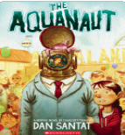***The Aquanaut*** by Dan Santat

Five years after her father dies at sea, Sophia is living with her uncle Paul at the Aqualand marine theme park. When she encounters a robotic "aquanaut" breaking into the theme park lab, Sophia is surprised to discover it's piloted by four plucky sea creatures who discovered her fathers equipment and journal. They are there to rescue their ocean friends, and Sophia is determined to help them succeed.

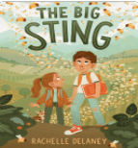***The Bioft Stinoft*** by Rachelle Delaney

Leo, Lizzie, and their parents, extend a family vacation by stopping to visit their Grandpa on his Heron Island, Canada farm. Leo has never met someone so grumpy, but his mother says it's because he's grieving their grandmother, a beekeeper. Leo, who prefers taking risks via video games, rather than in real life, unexpectedly grows closer to his grandfather when he joins Lizzie and him on an adventure to discover the culprit behind grandma's missing beehives.

***Bound for Home*** by Meika Hashimoto

After being placed in a foster home with Meili and Jim, Emi is allowed to have a pet and picks out a misbehaving dog named Max who has a tendency to run away. When Emi learns changes will be happening in her family, she decides to run away with Max into the Maine woods outside her home. A stray cat named Red who'd once helped Max return home, decides to go after them and help them both find their way back home.

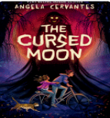***The Cursed Moon*** by Angela Cervantes

Rafael Fuentes loves ghost stories and scary books, and even is a good tale-teller himself, delighting to scare his friends with stories he makes up on the spot. That is just what Rafa is doing when he makes up the story of the evil ghost known as the Caretaker, who lures kids into his pond never to be seen again. After telling this tale, strange things start happening around him, and Rafa is horrified to find that his story has brought the Caretaker ghost to reality--and it is after him.

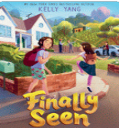***Finally Seen*** by Kelly Yang

When ten-year-old Lina Gao leaves China to live with her parents and sister, after five years apart, she must reckon with her hurt, anger, and curiosity and find a way to get her bearings in this new country-- and the almost-new family that comes along with it.

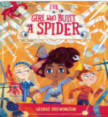***The Girl Who Built a Spider*** by George Brewington

After winning the County Science Fair, Theresa Brown, second-place winner Ashley, and third-place winner Jon, garner invitations from local inventor and scientist Dr. Flax to work in his laboratory for the summer and help him build a machine that will solve climate change. Theresa is all-in until she receives a mysterious late-night visit from a boy called Thomas Edison who implores her to help him stop Dr.

Flax from creating a machine that will destroy the world.

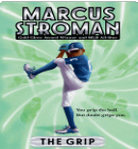***The Grip*** by Marcus Stroman

# Young Marcus Stroman is determined to make it to the highest playing level he can, despite every coach telling him he’s not tall enough to become a “real” pitcher. He’ll show them…with some struggling and a whole lot of learning.

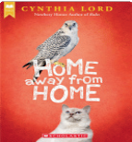***Home Away from Home*** by Cynthia Lord

Mia is spending her summer with her grandmother in a small Maine town, expecting it to be an oasis of stability in her changing life, but there is a new know-it-all boy next door, and soon she finds herself competing with Cayman in identifying an injured bird of prey--and pretty much everything else.

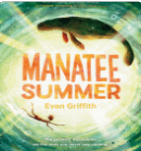***Mannatee Summer*** by Evan Griffith

Peter and his best friend Tommy have big plans before they both enter the sixth grade, namely, to document 100 creatures in their home state of Florida before summer ends. The only two members of their Discovery Club, the boys find a manatee in a river and take on the task of protecting it when they learn it's injured. Their exciting summer turns sour when Peter learns that Tommy will be moving away. Coupled with pressures to care for his ailing grandfather who has Alzheimer's disease, Peter is forced to face the difficulties in his life whether he wants to or not.

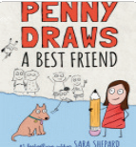***Penny Draws: A Best Friend*** by Sara Shepard

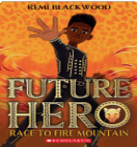Nobody said starting fifth grade would be easy, and Penny Lowry's anxiety means a million questions are always spinning through her thoughts. Luckily she's got a lot to look forward to, like her favorite after-school activity, Art Club, and seeing her best friend Violet again after spending the whole summer apart.The thing is, Violet has been acting weird ever since she got back. She never wants to hang out anymore, says Art Club is for babies, and spends all her time with Riley, the meanest girl in school. Did Penny do something wrong? And if she did, can she undo it?

*Future Hero****: Race to Fire Mountain*** by Remi Blackwood

# When she adopted Gus, Roo, Tank, and Moon Pie, Miss Lottie rescued each member of the pack and turned them into a family. But when a new dog, Decker, arrives and tries to hoard Miss Lottie’s heart and home for himself, the pack’s future is threatened.

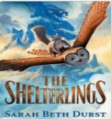***The Shelterlinofts*** by Sarah Beth Durst

Holly the gray squirrel was meant to be a wizard's familiar, but her only magic capability is to conjure up pastries-tasty, but mostly useless to wizards. Holly lives at the Shelter for Rejected Familiars, until an old friend comes up with an idea for her and the others to cure their supposedly defective magic. Holly and her friends embark on a quest to get ingredients for a special potion that can cure them, but along the way they may just discover their unique magic is just what they need.

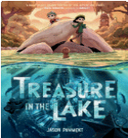***Treasure in the Lake*** by Jason Pamment

Friends since grade school, adventurous Iris and homebody Sam, wander together around their small village of Bugden to satisfy Iris' wanderlust. When they happen upon a dry riverbed at the edge of town, they discover an abandoned city that used to be submerged below the water. There they meet a mysterious girl named Lily, who gladly takes them on a tour. However, Sam and Iris have questions about the girl, namely, whether or not she is a ghost and whether or not they can return from wherever she wants to take them.

***The Ultimate Goal:*** *The Good Sports League* by Tommy Greenwald

Ben Cutler loves playing soccer for the Anchovies, a casual recreation league team, and he's really good at it. Then he is recruited for an elite travel team and playing on this team is intense. Although Ben is winning with this team, he's not having fun. Now Ben must make an important decision about his future in soccer.

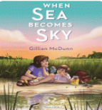***When Sea Becomes Sky*** by Gillian McDunn

Bex and Davey's summer in the saltmarsh is different this year, thanks to the record-breaking drought. Even the fish seem listless-and each day the water level lowers farther. When they discover a mysterious underwater statue, they're thrilled at the chance to solve the puzzle of its origin. When they learn of a development plan that will destroy their special spot, they'll need to act quickly. Unfortunately, sometimes progress and change happens, whether you're ready or not.