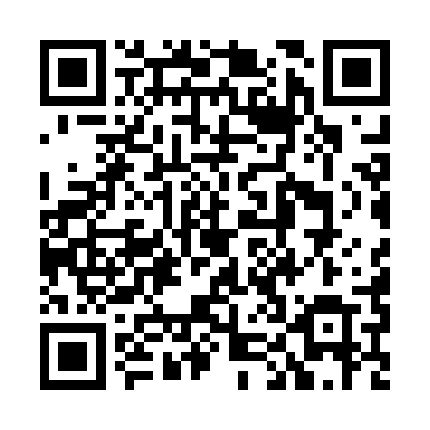

Location: Woodland Media Center

Date: January 13, 2022

Time: 8:50 A.M.

Notes: Light breakfast items served.